

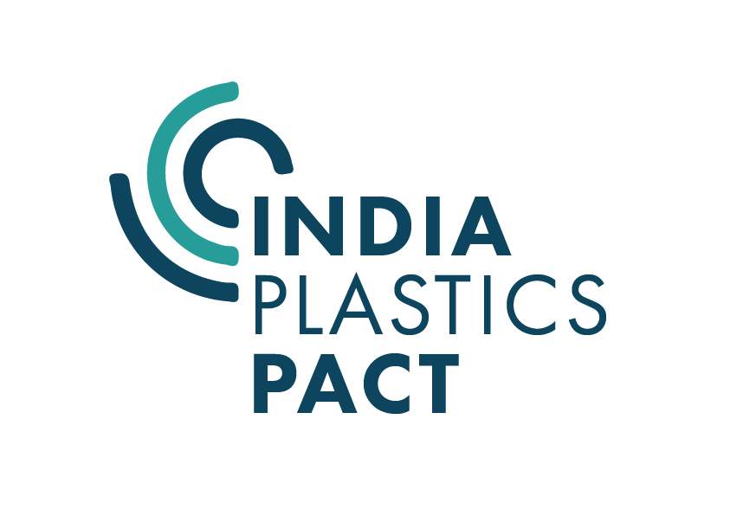

Application form: Technofinancial bid for Recyclable flexible plastic packaging solutions

Supported by


Project funded by
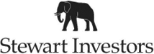

Technofinancial bid for Recyclable flexible packaging solutions
Application form
Thank you for your interest in submitting the technofinancial bid for a solution in the India Plastics Pact recyclable flexible packaging project. The application form consists of three parts:
- Part A (Lead applicant information)
- Part B (Consortium member details), and
- Part C (Technofinancial bid).

Please review the instructions below before filling the form.
- The application form must be filled and submitted only by the lead applicant (brand or converter that is a member of the India Plastics Pact). It is assumed that the lead applicant has formed a consortium before applying.
- The applicant must have read and accepted the terms and conditions provided with the application form.
- The applicant must fill out every field in Part A, Part B and Part C of the application form correctly.
- Please type your responses in Calibri font, size 12 and strictly adhere to the specified word limit for each section.
- Ensure that your application is submitted via email before the specified deadline. Late submissions will not be considered.
- When submitting your application via email, use the standardized file naming convention “CompanyName_Technofinancial bid” for easy identification.
- Ensure the documents are submitted as PDFs.

All information provided in the application form will be treated confidentially.
The provided contact details will be used for all communications related to the technofinancial bid.

Email the completed application form along with the project proposal to ippaction@cii.in

Deadline for submission: 1700 hours India time, 5 July 2024

Part A: Lead applicant information

1. Registered company name
Provide the full and official name under which your company is registered in India.

2. Company description
Provide a brief background of the company and products and markets (regional, national, and international) your company works in (max 100 words).

3. PAN |  | 4. GST
Provide your company's PAN for tax purposes. |  | Provide your company's GST number.
5. Registered address
Provide the registered address of your company. Please make sure it tallies with the GST details mentioned above.

6. Primary contact person details
Provide the name, designation, and contact details of the primary contact person in your company for this project.
Name: |  | Designation:
Email: |  | Mobile number:
7. Details of the proposed team members
Provide the details of core team members from your company who will be involved in the bid. Please indicate the designated project lead.
(Add or remove rows, if required)
Name | Designation |  | Lead
 |  |  | ☐
 |  |  | ☐
 |  |  | ☐

Part B: Consortium partner details

Provide details of the consortium partners
Company type | Company name | Contact person | Designation | Role in the project (max 30 words)
Choose an item.
Choose an item.
Choose an item.

Part C: Technofinancial bid

1Solution title (max 10 words)
Click or tap here to enter text.
2. Solution details
2.1 Category of the product to be trialled
Choose an item.
2.2 Name of the product to be trialled
Click or tap here to enter text.
2.3 Product SKU
Number of SKUs to be trialled (maximum two SKUs are allowed)
Choose an item.
Please provide the following details for the selected SKUs.
(If the trial is intended only for one SKU, please write “NA” in the SKU 2 field)
2.3.1 Size of the SKU
SKU 1 |  | SKU 2 (select only if applicable)
Click or tap here to enter text. |  | Click or tap here to enter text.
2.3.2 Annual production quantity of the SKU (number of units)
SKU 1 |  | SKU 2 (select only if applicable)
Click or tap here to enter text. |  | Click or tap here to enter text.
2.3.3 Annual production of packaging (tonnes)
SKU 1 |  | SKU 2 (select only if applicable)
Click or tap here to enter text. |  | Click or tap here to enter text.
2.3.4 Current packaging structure
SKU 1 |  | SKU 2 (select only if applicable)
☐Multi-polymer multi-layer flexible packaging  (plastics only) |  | ☐Multi-polymer multi-layer flexible packaging  (plastics only)
☐Multi-material multi-layer flexible packaging |  | ☐Multi-material multi-layer flexible packaging
2.3.5 Current packaging composition (specify polymer and material combinations)
SKU 1 | SKU 2 (select only if applicable)
Click or tap here to enter text. | Click or tap here to enter text.
2.4 Have you identified the mono-material film(s) to be trialled? If yes, please specify.
Click or tap here to enter text.
2.5 If you have identified the mono-material film(s), explain its suitability for recycling at scale in the Indian context (max 300 words).
Click or tap here to enter text.
2.6 Describe the scale of the proposed trial including the number of packs to be manufactured (max 200 words)
Click or tap here to enter text.
2.7 Describe the comparative testing the new pack will undergo (max 200 words)
Click or tap here to enter text.
2.8 Have you identified the location for market testing of the new packaging? If yes, please specify.
Click or tap here to enter text.
2.9 Describe your approach to testing the product in the Indian market, specifying the time frame (max 300 words).
Click or tap here to enter text.
2.11 Have you considered a communication plan about the packaging design changes to consumers and waste pickers, if the trial is successful? If yes, please provide an outline (max 300 words).
Click or tap here to enter text.
2.12 Outline any effort undertaken by your company to move to more recyclable film packaging in the past or currently. Highlight any learnings that will be applied to this project (max 300 words).
Click or tap here to enter text.
(A diagram or illustration explaining the action plan of your trial can be included separately with the application as an Annex).
3. Solution delivery
3.1 Describe your business capability to demonstrate this solution in the required timeframe, including relevant expertise and track record (max 300 words).
Click or tap here to enter text.
3.2 Mention the resources you will require to demonstrate the t solution and how quickly you can mobilise them, including any external resource/consultant (max 300 words).
Click or tap here to enter text.
3.3 Provide your project plan and timeline in the form of a Gantt chart.
Please prepare the chart on a separate page and enclose it with the application as an Annex.
4. Future plan for the solution
4.1 Describe the measure of success that would enable you to transition to this material specification.
Click or tap here to enter text.
4.2 Describe your plan to support the development of your solution following the completion of the demonstration if it is successful (max 200 words).
4.3 Mention and explain barriers to adoption of your solution and your plan to overcome them (max 300 words).
Click or tap here to enter text.
4.4Describe the impact of the trial on your business and EPR commitments (max 200 words).
Click or tap here to enter text.
5. Risks
Briefly describe the main risks for this project, including any project inputs that are critical to completion, such as resources and expertise. Consider any risks of reduced shelf life (for food) or product damage/wastage etc. How will you mitigate these risks? (max 500 words)
Click or tap here to enter text.
6. Budget
Break down the budget for your proposed demonstration of solution, specifying how the considersation will be utilized. Also, mention any expenditure (both ‘in-kind’ and identified expenditure) you plan to incur- including elements such as (but not limited to) staff time, line trial costs, material costs, testing or evaluation costs and consumer testing costs.
Provide the budget details in a separate Word document or Excel sheet, and enclose it with the application as an Annex.
7. Additional information
Provide any additional information that you think is relevant to support your proposal and enhance its competitiveness (max 500 words)
Click or tap here to enter text.

TERMS and CONDITIONS
Eligibility
The lead applicant must be a brand or convertor registered in India and a member of the India Plastics Pact. The product proposed for the trial must be sold in the Indian market.
The amount paid as consideration should be utilized for the purposes outlined in the submitted proposal and in accordance with the budget breakdown therein.

Reporting
The applicant agrees to share the key findings, learnings, and insights from the trial with the India Plastics Pact Secretariat (at CII) throughout the period of contract. This information will be disseminated by the Indian Plastics Pact in the form of a case study and webinar (potentially also a press release and further channels). All publications or outputs will be shared with the applicant before release. Confidential or commercially sensitive information or data will NOT be shared as part of the trial.

Compliance
- CII reserves the right to reject any application, if at any time a material misrepresentation is made or uncovered.
- Lead applicants of selected bids shall execute a separate service agreement with CII.

Confidentiality
CII shall not in any way be obliged to reveal, or discuss with any applicant, how an application was assessed, or to provide any other information relating to the evaluation/selection process or to state the reasons for elimination, to any applicant.

By signing this application form, applicant agrees to hold CII harmless from any disputes
Declaration (to be signed by the official in the lead applicant)
I, (enter your name here), declare the above information is true and correct.
☐ I have read, and I agree to the Terms and Conditions of the challenge.
(Please print, sign, scan and submit this page with your application).
Signature
Date:
Designation:

